**1.mean, meadian ,mode,standard deviation:**

**ALGORITHM:**

**Mean=** sum of observations/no of observation

**Median=** mid element of given list (or) n1+n2/2

**Mode=** most occurance of given elements.

**Stardard deviation=**square root of the variance

**SYNTAX:**

**d<-c(3,4,5,6,7,8,9,12)**

**Mean**: mean(d)

**Median:** median(d)

**Mode:** mode(d)

**Standard deviation:** sd(d)

**OUTPUT:**

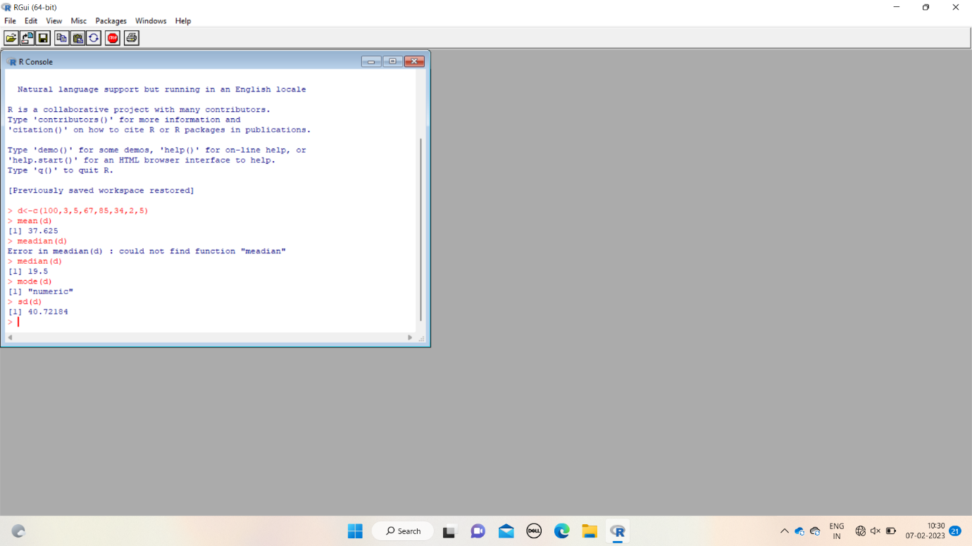

**2.bar plot,scatter plot,box plot,histogram:**

**ALGORITHM(syntax):**

**d<-(3,5,6,7,8,9,4,3)**

**Bar plot:** bar(d)

**Box plot:** boxplot(d)

**Histogram:** hist(d)

**Scatter plot:**  plot(d)

**OUTPUT:**

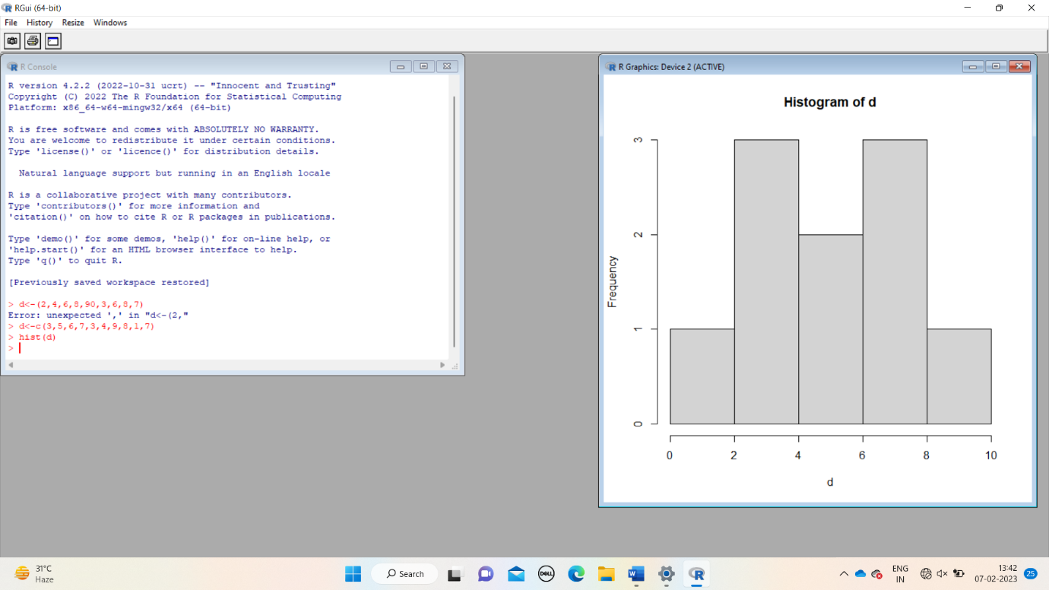

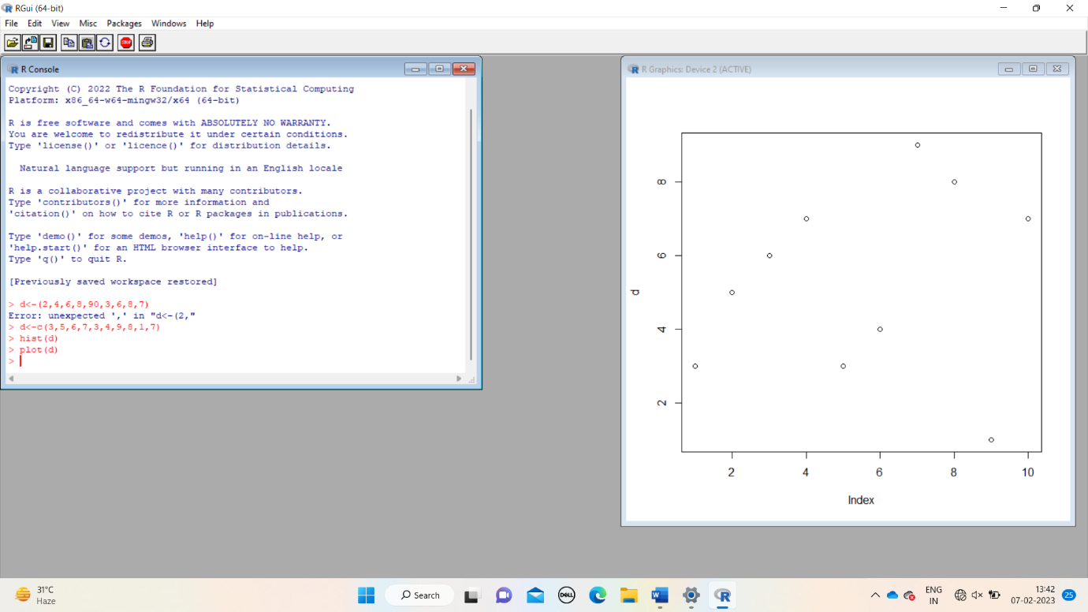

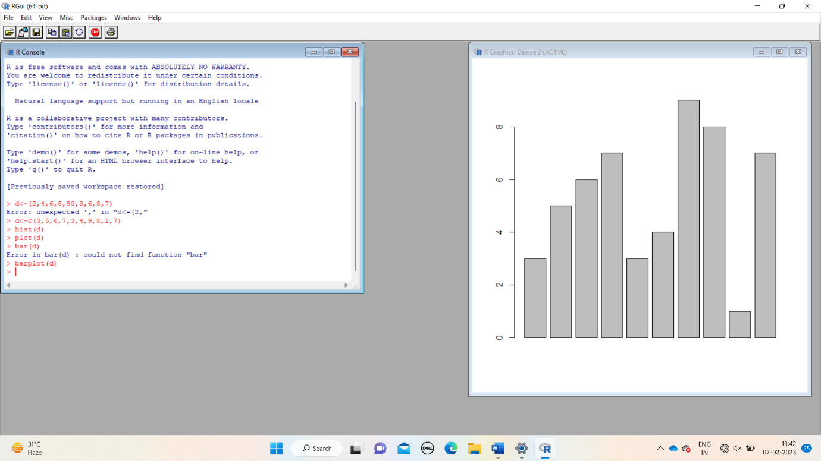

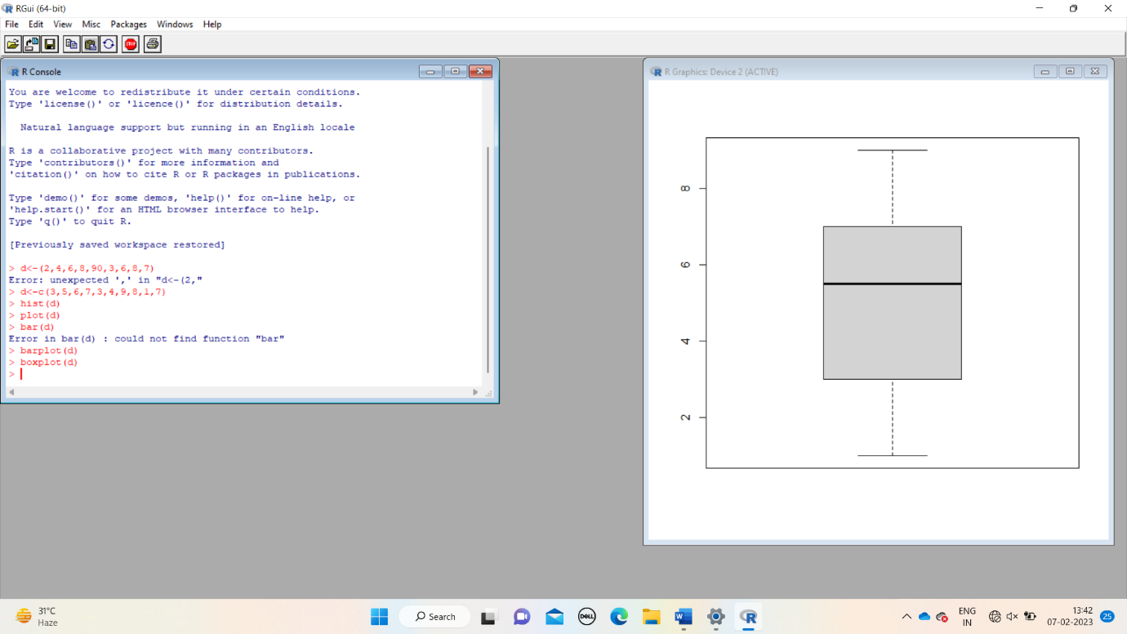

3.linear regression and multiple regression: